**Resolution stage: Harpreet singh**

**Bugs Fixed in the given entities:**

In the resolution stage, I have fixed the bugs in the entity class Booking.java, Hotel.java, and Room.java. However, the minor syntax errors are fixed and further, some statements are to run the program in a specific manner. The fixed bug screenshots are given below:

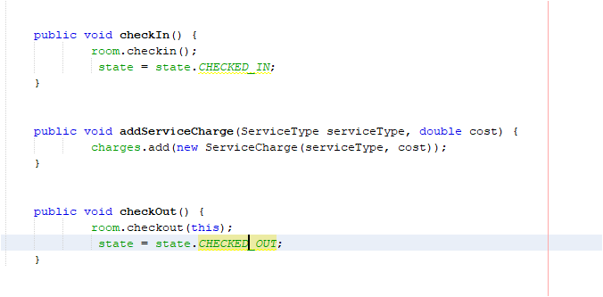

In the above picture, there are three bugs fixed in the entity Booking.java which are:

Statements added: state = state.CHECKED_IN

and, state = state.CHECKED_OUT

As well as minor syntax error is fixed from double SS to single S.

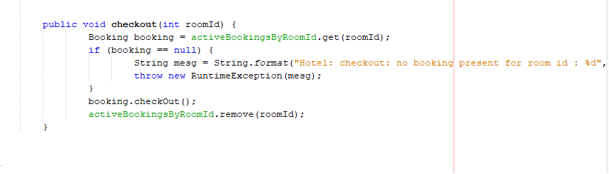

In the above picture the bug is fixed, and the statement is added to the entity Hotel.java and the added statement is given below:

Statement added: activeBookingsByRoomId.remove(roomId)

This will remove the booking from the system the guest ask for the checkout and no additional charges will be added to the room service after the checkout.

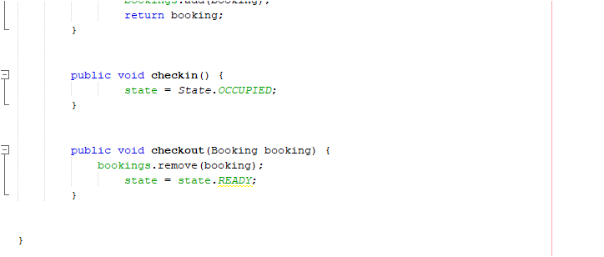

In the above picture, the statement is added to the given entity Room.java. The added statement is given below:

bookings.remove(booking)

However, we I have run the main class again, if the we ask for the recorded service and the system will ask for the room number by typing the same room number which was already checkout, it displays invalid room booking.

**User tests after corrections:**

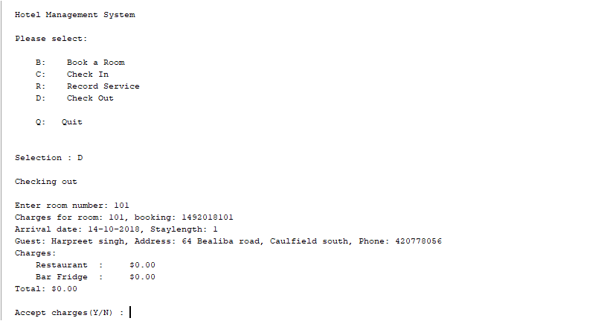

The above picture shows the user test after the bugs are fixed and now the exact charges will be displayed by the system at the checkout process.

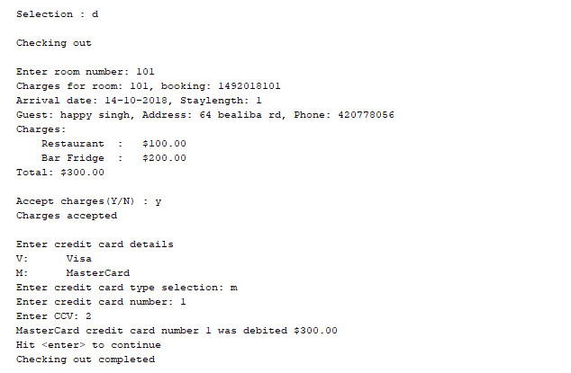

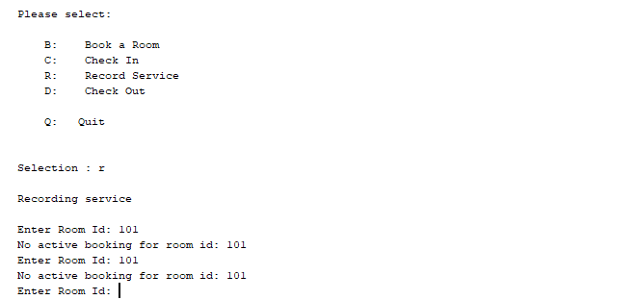

The above picture shows that state of the room is changed to checked out or on active booking even and no extra room service charges will be valid anymore**.**